Karibu Kenya: Culture and Agriculture in Africa

International travel is one of the best ways to learn about lifestyles in different regions of the world while being faced with situations that build more experience in one day than an entire week in a classroom. This was exactly the case with a recent trip I was fortunate enough to be a part of to Kenya, Africa that took place over the course of 12 days. It was a life-building trek that I will always remember vividly and gave me a new appreciation for the things in my life I take for granted.
It started with a simple email about an international trip heading to Kenya. I was instantly interested and decided to look at my options. The funding happened to fall in place and the timing was right. After an introductory meeting, I was well on my way. This was the second time I have travelled internationally, and the best trip I have ever taken.
I arrived on a cold December afternoon at Denver International Airport only to find out that our flight had been delayed. The whole group was worried this may be a sign of things to come for the rest of the trip. Due to the flight delay, it was possible I could end up going through Amsterdam instead of our scheduled London transfer. Luckily we all made it to London albeit with no time to spare. The next flight was leaving in minutes as we were ushered as a scrambling group through Heathrow International Airport, to arrive on the plane as it was already in motion before we could take our seats. We had successfully made it on our way to Nairobi, Kenya.
During the next few hours of available daylight, we flew at approximately 38,000 feet above many interesting terrains. Shortly after departure from London, the Alps just outside of Geneva, Switzerland came into view as a large expanse of rugged, snow-capped mountains. Very soon after, the Tyrrhenian Sea filled the tiny cabin window with an expanse of ocean in full scope. Just before sunset, we were over the Libyan Desert filled with blistered red sand over a smooth surface with insignificant ripples of wind-blown features. There wasn’t a human, animal, or body of water in sight, again as far as the eye could gaze. Even in the night, there were detectable signs of human life down in the jungle surrounding the Nile River as we crossed. Massive strings of what appeared to be fire were occasionally glimpsed. These looked to be miles long and I still wonder what their purpose was.
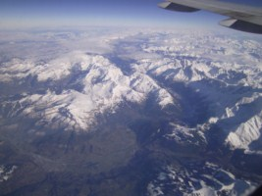
The two excruciatingly long flights were finally over as the captain announced “we are about to arrive in Nairobi” during our egress from above the clouds. The first thing I noticed while coasting above Nairobi was the scarcity of city lights. I am used to sprawling views of large American cities like Denver at night, whereas this city was not nearly as bright or extensive even though the populations are very similar. I also noted from our elevated view, fewer cars on the roads that were driving in the opposite directions from what I was used to.
After leaving the plane, the airport scenery was very different from the previous two. The hallways were much smaller and lacked the superfluous atriums like Heathrow or DIA. The airport overall was not grand in scale and was obviously older with a much smaller budget. As we came to the customs desk I found a window that was not made of glass, but of bricks with holes open to the outside. This was a very pleasant surprise as I was just in below freezing weather for the last couple of months. This also explained the temperature as it was roughly 80 degrees and quite humid inside. Having buildings open to the atmosphere was a commonality that was soon to be realized over in Kenya, as the climate is typically constant enough for it. For the first time in my life, I have been in a place that heating and cooling wasn’t necessary.
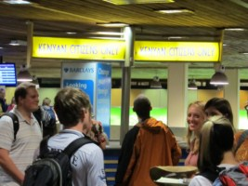
After finding out everyone’s luggage had been delayed except for one lucky student, we made our way outside to a small Mitsubishi bus. A short drive from the airport was a checkout station and then on to the start of our stay in Nairobi. We soon found out there were no speed limits as the bus driver was going what seemed like much faster than American drivers while being passed by cars travelling even faster. Traffic was fairly light, and the city in this particular area was sparsely populated by the occasional office building and petrol station. In the first couple miles of our trip in Africa, we had already encountered many smells I have never been exposed to back in America.
The drive to our destination took us through about a half hour of rural roads. It was too dark to make out much detail other than green grass and many people walking around seemingly out in the middle of nowhere. We passed many estates that were all fenced in with security signs posted and finally found Eshel Gardens, where we stayed for the next couple days.
Eshel Gardens is a Christian-based hostel located outside of Nairobi. The project named “Springs of Africa” was founded by the brother of our African correspondent, Emmanuel Omondi in 2002. Springs of Africa is focused on community service projects such as social welfare and assistance programs, community development, income-generating activities and training at various levels (http://www.springsofafrica.com/about.html). The property has a few houses, guest rooms for up to 20 people, eating hall and a small agricultural project along with numerous tenants that live on the property full time.
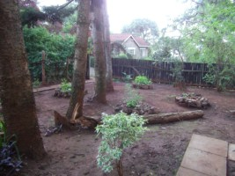
After assignment of our rooms upon arrival, we unpacked our bags and met soon after in the dining hall for our first taste of Kenyan food. There were large mugs of fresh Kenyan chai tea of which is a daily drink for most Kenyans, and something we were going to be enjoying plenty of ourselves made of boiled water, tea leaves, unprocessed milk and sugar. Along with sweet “biscuits” that we would call crackers, we were served with fried bread, Chapatti, which is unleavened flat bread much like tortillas and soon to be many of our favorite Kenyan food, samosas, which are meat-filled and fried dough triangles. After having a short introduction from every member of the group, it was time to get as much rest as possible before our early first morning in Nairobi.
Just after sunrise, which happens to be roughly 6:30AM year-around in Kenya as it is located on the equator, we took a short tour of the agricultural plots and greenhouse at Eshel Gardens. They grow numerous types of produce including melons and peppers, with the peppers strung up to allow for vertical growth. A simple system that helps raise yields and sustainability. This will be a continuing trend for the rest of our farm visits.
We left for the city right after a short breakfast of omelets with peppers grown at Eshel Gardens. The first stop was at a local market where everyone was able to exchange American Dollars for Kenyan Shillings, at roughly a 1:80 ratio. There was also a grocery store filled with many products none of us had ever seen before from curry fried potatoes and nuts to boxes of Mango puree. Prices weren’t surprisingly cheap and fairly comparable to U.S. rates.
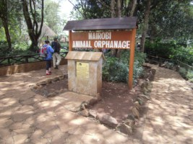
The group decided to make our next stop at the Nairobi Animal Orphanage. The orphanage was established in 1964 in Nairobi National Park right in the middle of the city. This is the only wildlife protected area in a capital city, in the world. While walking into the compound, there were baboons wandering all around us. Certainly a sight none of us were used to. Inside the orphanage, we were able to see many animals from Servals, Lions and Leopards, to Guinea Fowl, Zonkey and Crowned Cranes. The members of the group were even allowed into the Cheetah enclosure for quick petting and pictures.
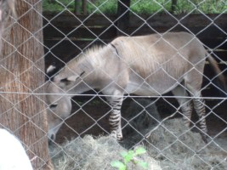
The next stop was a mall that featured Maasai Market, a collection of street vendors that sold handmade goods supposedly from the Maasai Tribe. The mall also had many shops including what were called Chemists; our version of a pharmacy, to restaurants and a grocery store that sold appliances and electronics. After a nice lunch in an open-top bistro, the group met outside to barter for goods. The street vendors are accustomed to haggling as part of their culture, as we were told it is even offensive to pay what they initially asked. Some members did excellent jobs of haggling, while others were very new to a process like this which resulted in overpayment for some goods according to our Kenyan correspondent. Fortunately I have been in this situation before and was able to obtain a hand-carved Rhinoceros from Ebony which is an extremely dense, black, jungle hardwood and is one of the few woods that sinks in water, for 1,100 Shillings or roughly 14 Dollars.
Nairobi is adjacently located to the Great Rift Valley of Africa. This is the only rift in the world that is actively splitting a continent in two, much like the Mid Ocean Ridges. Eventually, Africa will become two continents separated by an oceanic basin. The Great Rift Valley is 3,700 miles long and runs from Syria, Asia to Mozambique, Africa (http://en.wikipedia.org/wiki/Great_Rift_Valley).
Much like Denver, with a population of just over three million, the capital city Nairobi is the largest city in Kenya. Surprisingly this isn’t the only thing Nairobi has in common with Denver as it is located at 5,900 feet above sea level and occupies 270 square miles. The city was first established in 1899 as a supply depot on the railway between Uganda and Mombasa, in a swamp ecosystem. Nairobi was named after a Maasai name “Enkare Nyirobi”, which means “the place of cool waters”. As the city grew due to hunting and tourism, the Maasai were angered as they were forced out of their native lands (http://en.wikipedia.org/wiki/Nairobi).
After Maasai market, we went to a local club that had dancing and cultural shows, only to make it after everything was done. This was the perfect opportunity for the group to relax and enjoy the warm Kenyan evening to some different food and drinks. Most of us tried a lager beer called Tusker. Tusker is brewed and bottled in Kenya with 100% African ingredients that are from local sources. The barley comes from the Maasai Mara, water from the Aberdare Mountains, yeast, cornstarch and sugar all come from Kenya. This beer is a main staple in Kenya much like our Budweiser. We also tried some of the club’s sausages and samosas. The sausage over in Kenya, as I was going to experience many times more during our visit, is soft and mild compared to our version and made with pork. There was also a delicious and tangy Kenyan hot sauce called Peptang, which a few of us quite enjoyed. Enough so, that we made a stop at another local grocery store by the name of Nakumatt to purchase a few bottles on the way back to Eshel Gardens.
Back at Eshel Gardens, we were just in time for our first traditional Kenyan-food dinner. These courses are very common over there and comparable to the USA’s meat and potatoes, or burgers and pizza. Our meal was Lentil soup, seasoned-stewed chicken, Chapatti, steamed Kale and Ugali. Ugali is the most common staple starch in Eastern Africa. It is made from corn flour, white in color and dense in texture with a very mild flavor.
Next morning was our first stop at a sustainable farm project. This was located in Kamiti Maximum Security Prison. The portion we toured was the reform sector for boys between the ages of 17 and 21. The project was designed to teach young men basic skills in subsistence farming and production to allow them to become valuable members of society. They were also encouraged to spread these learned skills among others of their local area. These boys had various crops along with rabbits and goats. As we found out, rabbits are a fairly common source of meat in Kenya as they are small and easy to raise. We were shown a bin of “liquid manure” the prisoners were preparing for the crops made from a mixture of water and manure in a 2:1 ratio and left for 14 days to ferment. They also produced compost which consisted of leftover vegetable matter and worms and covered with mulch. The boys were also trained in techniques for making yoghurt, dish detergent, shampoo, bleach and mango sugar drinks among other simple products.
The next sustainable farm project was a ways outside of Nairobi called G-BIACK. G-BIACK is an acronym for Grow-Bio Intensive Agricultural Center of Kenya. This compound was founded in order to teach local Kenyans about sustainable subsistence farming along with other skills such as textiles and sewing, where women were instructed on how to make clothing, baskets and bead work to be sold at the local markets. As we would find along the rest of our trip, the selling of goods at local markets is a major source of income for many Kenyan families.
G-BIACK teaches environmental training where students learn skills such as planting trees. They also teach soil quality and how to not use chemicals in the production of crops. This adds to the sustainability and lowers the cost. Several other methods of farming were used including what was called a Manyatta garden. This is a circular garden with a hole dug in the center. The “core” as it was referred to is then filled in with manure. The idea is to apply water for the garden in the core and the surrounding plants will absorb the water along with natural fertilizer. G-BIACK also used methods the previous site had with subtle differences such as concentrated liquid fertilizer made from worm compost and liquid manure.
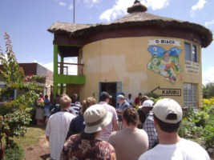
Two programs focused around livestock were also in effect. What was called the Rabbitry project, was a system where orphaned children from HIV/AIDS were given a pregnant rabbit. The children must return two offspring back to G-BIACK and can keep the rest. The other program was aimed at women’s groups with HIV/AIDS. A woman is given a goat to provide milk to the rest of the group. When the goat gives birth, the offspring must be given to another member of the group. This continues until the whole group has goats.
G-BIACK was also experimenting with intercropping, nursery production and bee keeping. The intercropping experiment was a system of corn and beans, both grown together in the same rows and grown in a series of alternating rows. They showed immediate results with beans grown in the corn rows due to the nitrogen fixation by the beans and uptake by the corn. The alternating rows produced nitrogen that would stay in the soil longer and not be available for uptake by the corn until levels were built up over time. Their testing methods weren’t the most regulated and had definite flaws compared to our testing methods back in the US. The nursery experimentation was with seed collection methods, seedling raising methods and seed storage. Honey bee keeping was an additional part of the program where students were taught how to raise and care for bees.
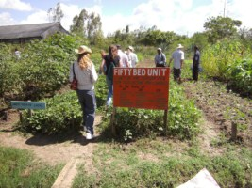
On the way back to Nairobi, we made a quick stop at a small farming operation in some highlands of Nairobi. On the way up the road, we noticed there were crops being grown everywhere possible. Large portions filled with 15 foot tall sugar cane were all around with many other plants including banana trees. The farm we reached was small in size but quite productive. The owner was kind enough to feed our entire group dinner, which was mainly the traditional Kenyan food along with a new dish much like Mexican Pico De
Gallo, made from fresh cut tomatoes, onions, cilantro and peppers. The farmer gave us a tour afterwards where he was raising 1,200 chickens, numerous generations of cattle and mushrooms. The chickens were kept in large coups approximately two stories tall. The cattle were fed sugar cane stalks that were cut into one inch sections by a gas-engine powered cutting wheel. The mushrooms were grown in small huts made from wood where they could be kept moist and dark, on a mixture of manure and mulch in individual bags that were inoculated from a jar of mycelium. The growing medium was sterilized onsite by a steam room. One notable facet of the farm was the fact every available piece of ground was used to grow some kind of crop, typically Kale.
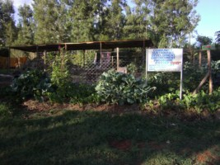
Later that night, the group was able to eat at a local famous restaurant called The Carnivore. This restaurant used to serve game meat from Kenya. Although this practice was outlawed in 2004, we were still able to eat some more exotic kinds of meat including crocodile, camel, ostrich, oxen meat and testicles, goat, lamb, turkey, chicken legs and gizzards and beef. This was an interesting and delicious experience for all of us.
Early the next morning, we set out for the Flamingo Flower Farm just outside of Lake Naivasha, approximately 1.5 hours from Nairobi. This farm is composed of many greenhouses where roses are grown with the water from Lake Naivasha. There is controversy over this practice as the lake’s ecology is greatly affected due to eutrophication of the water along with pesticides and contaminants that are killing the wildlife. The lake’s size has also been drastically reduced as there are many other flower farms in the area. The representative of Flamingo Flower Farm assured us they are doing everything they can to preserve the lake’s resources and are not contributing to the downfall of the ecosystem.
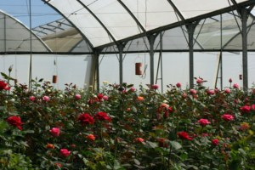
The farm uses a system of drip irrigation where the flowers are grown in pots filled with a pumice and coconut husk mixture that ends up being a mostly hydroponic system. There is a system of trays underneath the rows of pots that collect the runoff for approximately a 30-40% recycling of the water according to the representative. This method was definitely inadequate to the naked eye, but Kenya doesn’t have nearly as strict of regulation as the US would.
The flower farm also uses a form of IPM, or Integrated Pest Management for fungal and insect problems. A series of sulfur cans were hung around the greenhouses and vaporized at night for fungal control along with mycorrhizal inoculant. The greenhouses had curtains for walls that were also drawn open at night to prevent moisture buildup. Sticky traps for insects were used with a last resort of chemical forms of control.
The farm used an extremely expensive unit designed to filter the recycled water. This unit was a setup of tubes with micro-holes that would force the water through. This removes all pathogens such as bacteria and fungi, but preserves nutrients for the water to be reused. The farm also had a few wetlands for runoff water to be processed in. The idea was to reduce the amount of nutrients before being drained back into Lake Naivasha. Again, we were skeptical.
On our way to the hotel we were going to be staying at that night, we made a stop at Hell’s Gate National Park which is south of Lake Naivasha. Hell's Gate National Park is named after a narrow break in the cliffs, once a tributary of a prehistoric lake that fed early humans in the Rift Valley (http://en.wikipedia.org/wiki/Hell's_Gate_National_Park). Hell’s Gate is at an elevation of 5,000 feet, has an area of 26 square miles and was founded in 1984. The park also is very geothermally active and has three power stations that utilize this free source of energy.
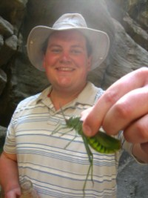
Once we arrived at the ranger station, a guide was assigned and we chose to take a three hour hike through the canyon. The terrain was mostly smooth rocks with fine sand and very dry. The plant life around the canyon was mostly shrubs and trees. The hike led us through several legs of the narrow canyon with cliffs at least 50 feet high on either side. We encountered several animals including many wasps, large grasshoppers, snakes and even a Rhinoceros. Along the way down a stream, the ranger showed the group two very warm hot springs that were flowing out of the side of the canyon. On the way out of the park, the group was fortunate enough to see a decent amount of wildlife which was just a primer of what was to come later on. The animals included Water Buffalo, Impala, Guinea Hens, Warthogs, Zebra, Gazelle and Ostrich.
After a night of sleep at the hotel in our next destination Kericho, we took a tour of the local tea fields and factories. Kenya is the third highest producer of tea in the world just behind China and India. Not many countries in the world have the proper climate to facilitate tea production. Although the average Kenyan consumes around 400 grams of tea per person per year, they still export 95% of their tea.
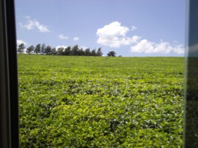
The first stop was a tea factory started in 1937, where prepared tea is received and packaged. Their annual production is roughly 9.5 million kilos. Upon entrance, we were required to wear lab coats and walk through a shoe wash solution to prevent contamination. In order to produce the right tea, they blend eastern and western varieties at up to six different types together. This gives effects such as caffeine content, color and flavor differences.
In order to blend the tea properly, the workers must taste test the incoming varieties. They grade the tea by taste, strength, bitterness, softness, sweetness and acidity, with acidity being a good trait. There is quite a process the tasters follow in order to get an accurate reading. They taste by the spoonful by swishing in the mouth, never swallow, with water to follow each taste to cleanse the palate. The testers can only take 15 teas at a time before the mouth can’t discern well enough.
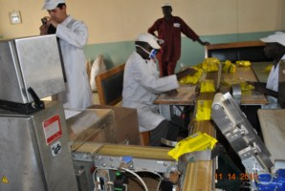
All incoming tea is run through a 2,500 US Dollar magnet to remove any metallic particles. This is supposedly a process that ensures greater quality as most producers don’t take this practice.
The machines used to package the tea bags are two million dollars each. They prefer to use expensive machinery due to reliability and to prevent easy counter fitting of their brand of tea bags. The machines do not have many problems partly because the product is dry and doesn’t gum up the mechanisms much like a product like cheese for example. The newest machines are computerized, where a report can be sent to the manufacturer during problems and the diagnosis can be done remotely.
Before the product leaves the factory in boxes, labels are attached for the country of destination. The boxes must be legally marked “for export” to prevent locals from bypassing tax laws by buying boxes destined for export and keeping them in the country.
We then headed out to the Kymulot Tea Plantation. The plantation was started in 1926 and covers an area of 6,000 hectares. They produce a total of 25 million kilos per year. The farm has 14,000 workers that live onsite with their own bank at the plantation’s entrance.
The tea fields are fertilized by an aerial method directly onto the leaves with 100kg of Nitrogen per hectare periodically. The fertilizer is applied just before 300cm of rain occurs to wash it down into the soil. Unfortunately, roughly 80% of the fertilizer is washed out into the local watershed and wasted.
Workers harvest the tea by two methods. The preferred method is by hand as this provides for a faster rate of regrowth since individual buds can be picked at optimal areas of the plant. Alternatively, they use a mowing method where a gas-powered machine shaves off the top few inches of leaves. This is much faster and provides a higher yield.
We made our way back to the factory where the tea is processed. This factory differs from the last in that fresh tea leaves are handled. The fresh leaves can be certified or uncertified. This is determined by the compliance to social, environmental and quality standards such as worker benefits and minimum wage. Rainforest standards include waste management, environmental impact and growth conditions.
The tea leaves come in from the fields with 80% moisture, where they are dried on large screen beds down to 70% moisture. Desiccated air is circulated around the leaves. The plantation has large groves of Eucalyptus trees to provide fire wood for use in drying the air for this process.
Now the leaves are chopped and fermented. The fermentation process takes 140 minutes to complete. The fermentation is just a term they use to describe this process as it is oxidation instead of bacterial processing. As the chopped leaves are exposed to the atmosphere, the internal alkaloids are oxidized into large amounts of caffeine compounds. This turns the leaves from green into a dark brown color.
The dust is then blasted with additional hot air to further remove moisture. After cycling through electrostatic extractors to remove fibers from the leaf material to produce pure leaf, the dust is separated by particle size into separate bins. The particle size determines different types or qualities of tea. The tea is then packed into bags, vibrated to increase density and contains 3% moisture at that point.
After the tea plantation tour, it was time for our fairly long drive to our next destination outside of Kitale, the Manor House. Manor House is directed by our Kenyan correspondent Emmanuel Omondi. They are another educational organization designed to teach subsistence farming and other agricultural production. The facility was started in 1984 after a severe drought that caused widespread hunger in Kenya. 75% of Kenyans make their living from farming, and over 85% of these are small-scale, family farmers (http://www.mhacbiointensive.org/aboutmhac.html).
During our stay at Manor House, we were shown their methods of production. They raise both crops and livestock including honey bees. The farm houses hogs, chickens, geese, goats, sheep, rabbits, dairy cows and donkeys. We had a hands-on experience with using the donkeys to plow a field. As we were there during the dry season, the ground was very hard which made it much more difficult to plow with penetration only being approximately ten inches at the most.
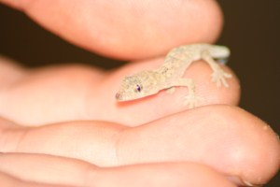
Later on we were educated on the crop production system. They employ composting where alternating layers of plant matter are stacked with dirt spread in between layers. The stacks end up being roughly four feet tall and steadily shrink over time as the microbes break down the plant matter into a smooth, dark substance. This compost is then used in a method called “double digging”, where the top layer of soil is removed and placed aside. The next foot down is then removed and placed aside also. Another foot of soil down is loosened and tilled, with the compost and top soil being placed on top, followed by the second foot of soil. This allows the plant’s roots to penetrate further and obtain nutrients from the compost that is now buried.
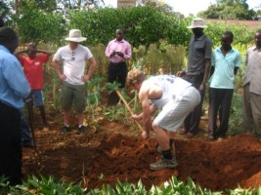
Our last agricultural stop was at another organization called the Macedonia Self-Help Group. This is another subsistence farming educational program that teaches BIA which stands for Bio Intensive Agriculture. This is another form of low input, high output, sustainable and chemical free form of farming that is influenced by the people of Manor House. Among growing many crops such as Artemisia Tea, which is an anti-Malarial medicine, Comfrey, Spider Hub, Cassava and beans, they have also engineered a solar drier for desiccating fruit and vegetables.
Before we left MSHG, we split into groups of men and women to speak with the Kenyans about their cultural gender differences. It came as a surprise to many of us that the women typically stay at home, while the men go to the local town and try to sell goods. Women in Kenya raise children, prepare and raise food and perform all chores around the home. If the men don’t have a job, which many do not, they spend their time in town trying to make any money possible. There is an obvious biasing in the work share between the men and women, with women doing most of the work. This was something we didn’t necessarily expect and very different from our culture in the US. Upon our exit, many children appeared out of nowhere to watch us leave. This was the first time they had ever seen Caucasians and were quite shocked.
After heading back to Nairobi, we stayed one more night at Eshel Gardens. The next morning we headed to Maasai Mara National Reserve. The park is named after the local Maasai people. It was founded in 1948 and has an area of 583 square miles. The reserve is a continuation of the Serengeti National Park in Tanzania. One of the greatest migrations in the world happens every year from Tanzania to Kenya through these two reserves by Zebra, Gazelle and Wildebeest (http://en.wikipedia.org/wiki/Masai_Mara).
After a very long and rough ride through rural roads, we had made it to our final destination and apex experience of the trip. We stayed at a nice hotel in a small river valley in the park. There was a large main lodge made from logs, a swimming pool, fire pit and approximately 20 guest tents. The tents were very deluxe with hard wood floors, and tile bathrooms. My thought on the idea behind not having a hard structure around the rooms was to allow for a more natural experience where guests can hear the surrounding animals. Power was supplied by a generator which turned off every night at 11pm, and the animals around would instantly start to make much more noise. I found this very interesting.
We were able to go on numerous game drives while there. The vans used were four wheel drive, turbo diesel Mitsubishis that had an extending roof to allow standing for picture taking. While on the drives, we came across a huge number of animals with four of the “big five” being encountered. The only one we didn’t see was a leopard. Many herds of zebra, wildebeest, topi, Thompson’s Gazelle and impala were everywhere along with a group of around 200 Water Buffalo at one point. There were various groups of elephants, giraffe and hartebeests. We also saw two groups of hippopotami and Nile Crocodiles. The most exciting finds were a male lion, lioness with a fresh zebra kill, a family of cheetah that had a fresh impala kill and a rhinoceros.
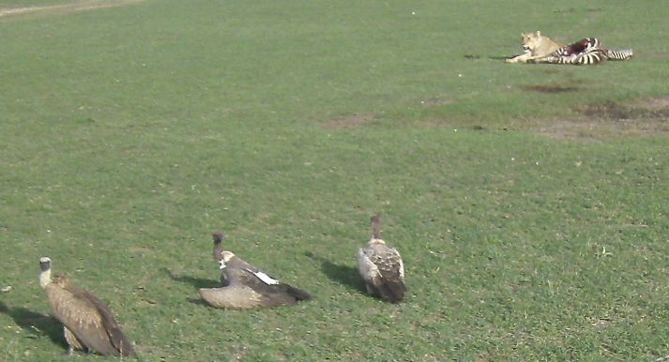
Unfortunately, amazing experiences like this can’t last forever, so we made our way back to Nairobi for the return trip to the USA. The group had been through a huge amount so far and learned even more. The cultural differences between us and the Kenyans were many and obvious at times. The trip was an overwhelming success, partly due to a great group of people. If the opportunity arises to visit Kenya again, I would take it before my heart could beat.

